Creating Github Actions Pipeline involving usage of Selenium-Python Automation Testing

Open github.com and login into it. Choose New to create new repository.

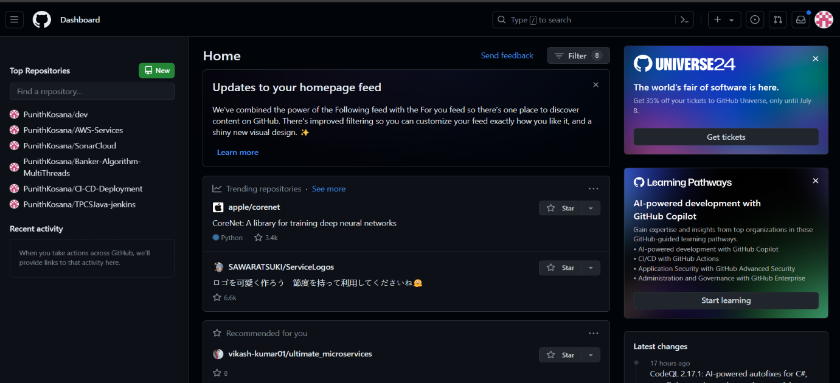

Name the repository and make it public. Choose Create Repository.

Install selenium.

This is the website we are going to deploy with github actions.

This is how website looks like.

Add the file into repo and commit changes.

File has been successfully pushed into the repository.

Go to Settings>Github Pages. Configure Static HTML. Make sure to choose the source as Github Actions.

This is the code used to deploy onto the github pages.

Commit the changes.

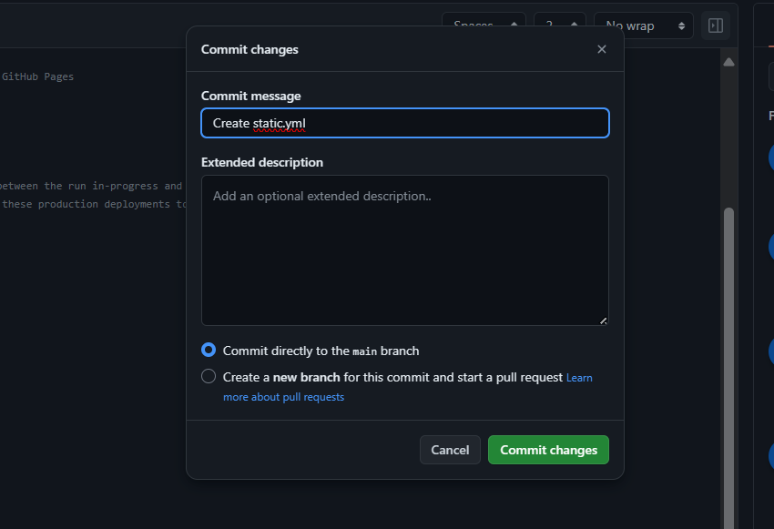

The github workflow has been created successfully.

Choose static.yml and click view runs. The deployment has been successful.

Open Github Pages and visit the site.

The website have been deployed.

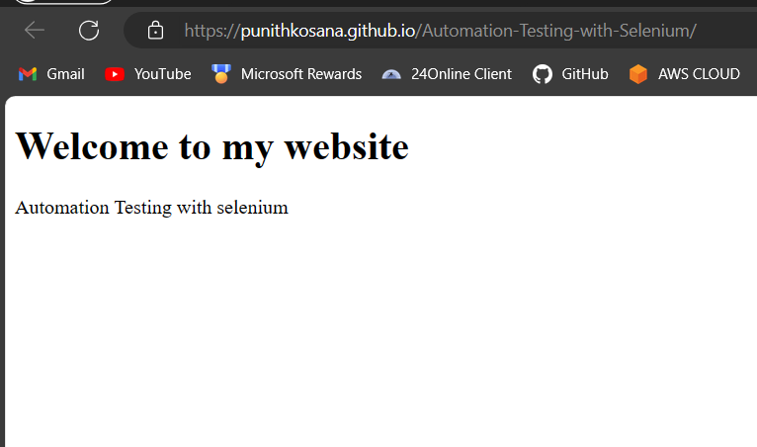

This is the python-selenium script used to automate the process. Whenever the changes made in the repo, the scripts executes and the screenshot of the website will be pushed into the repository automatically.

Upload the python file and commit changes.

Add these steps that has to perform and test at the time of deployment in the static.yml file.

Commit the changes.

The test has been executed successfully.

The deployment also done successfully.

The screenshot has been taken and pushed into the repository.

